Algebra 1: Unit 5, Lesson 1

- The equation, $x-5\left(x+6\right)=14$, is incorrectly solved in the table shown.
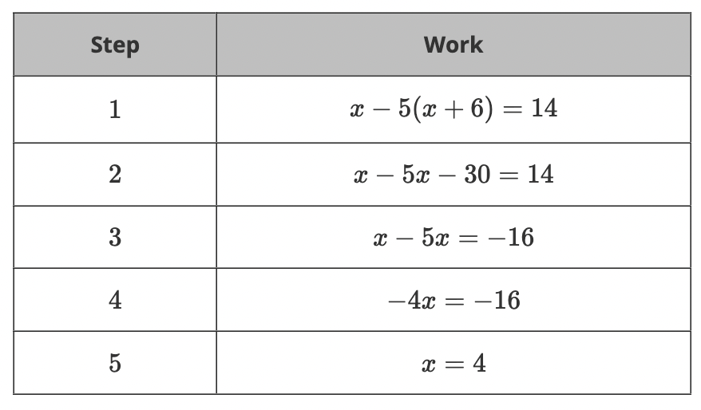
Which step has an error in solving the equation?
Step 3

- What value of $x$ makes the equation, $-7x+12=-5x$, true?
$$x=6$$

- The equation $5+3x-7\left(x+1\right)=9$, is incorrectly solved in the table.
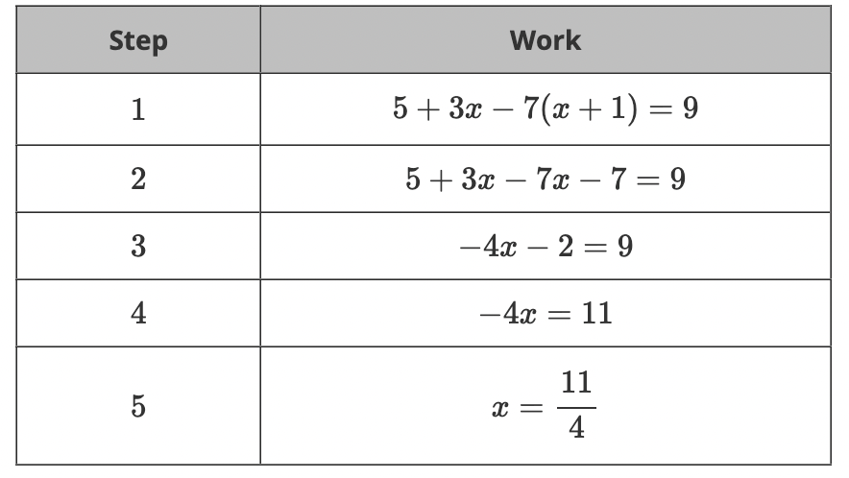
What is the correct value of $x$ that makes the equation true?
$$x=-\frac{11}{4}$$

